SHOPNEST STORE POWER BI CAPSTONE

Aayushi Agarwal

DAY-2024-07

Design a comprehensive Power BI dashboard to address key business analytics for a retail dataset. The following analytical questions should be answered through your dashboard:

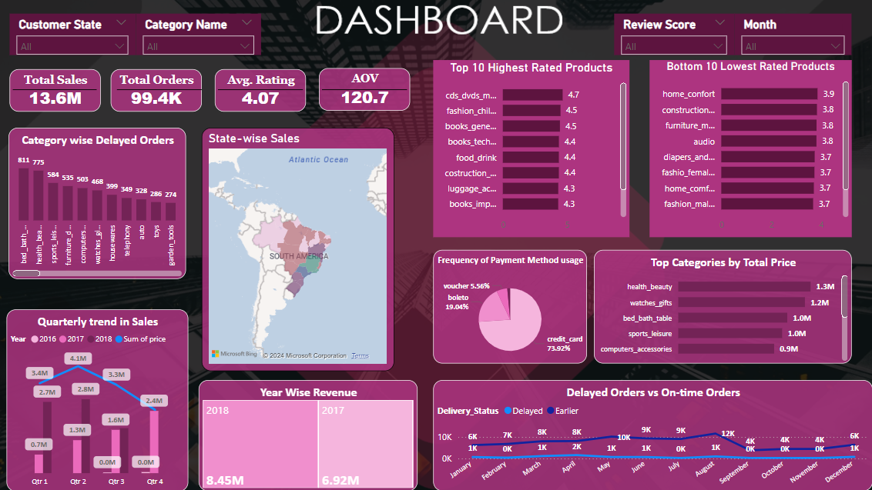

1. TOP CATEGORIES BY TOTAL PRICE

Identify and visually represent the top 10 product categories by total sales.

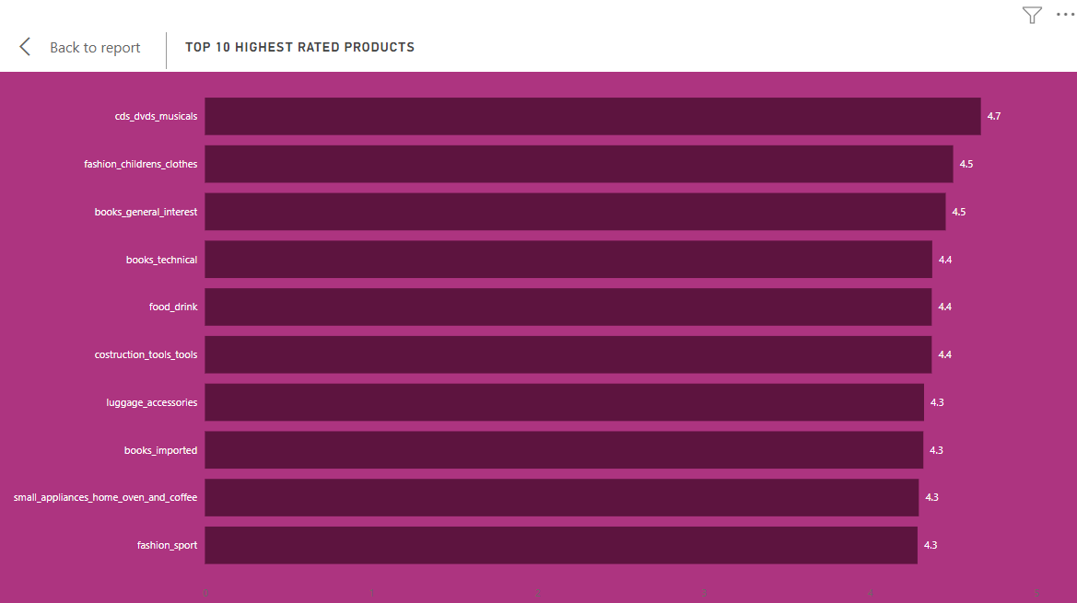

The bar chart visualises the top 10 product categories by average ratings. CDS_DVDS_MUSICALS has the highest average rating (4.7) followed closely by the visible categories.

1. DELAYED ORDER ANALYSIS

Determine the number of delayed orders in each category. An order is considered delayed if the actual delivery date is later than the estimated delivery date.

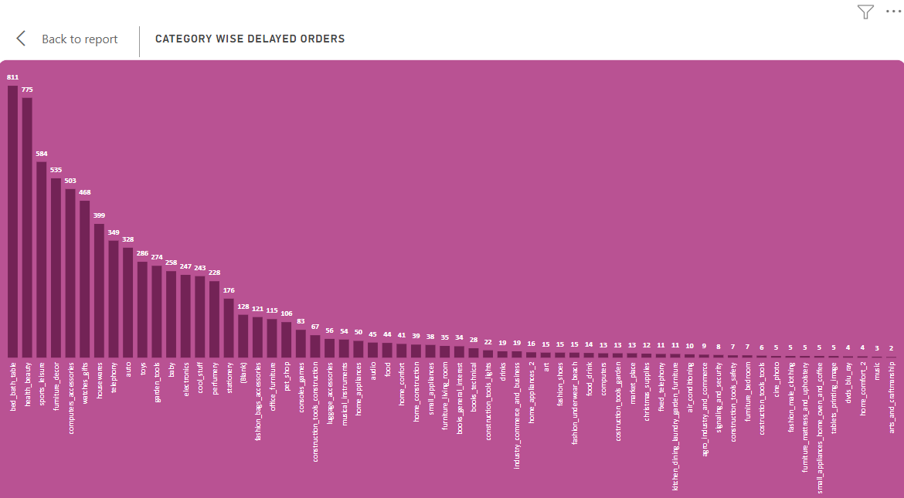

The bar chart shows the breakdown of delayed orders across a wide array of product categories. Notably, Bed bath table emerges as the category with the highest count of delayed orders, totaling **811**, indicating potential challenges in logistics and supply chain management within this segment. Party suppliers, Diapers and hygiene and Flowers demonstrate minimal instances of delayed orders, with only 1 each respectively, underscoring the efficiency in handling and prompt delivery within these product segments.

1. MONTHLY COMPARISON OF DELAYED AND ON-TIME ORDERS

Create a dynamic visual that compares the number of delayed orders to the number of orders received earlier for each month. Utilize the drillthrough cross-report feature to provide a detailed analysis of late and on-time deliveries.

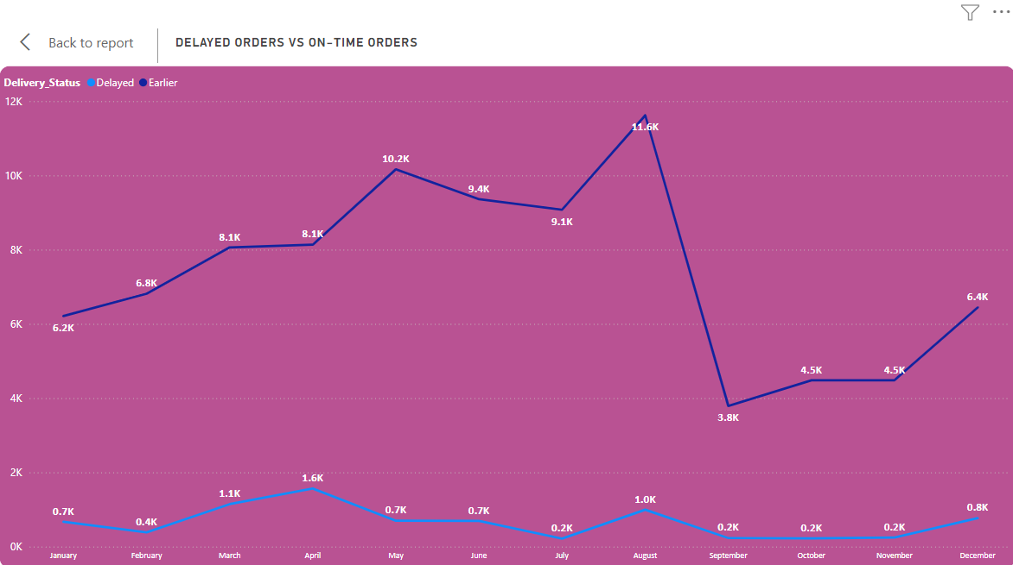

The line chart provides a detailed comparison of delayed and earlier orders across all months, offering valuable insights into order fulfilment performance throughout the year. August emerges as the month with largest disparity between delayed and early orders. December and January witness increased delays potentially due to heightened customer demand during the holiday season.

1. PAYMENT METHOD ANALYSIS

Analyse the most frequently used payment methods by customers using a visually appealing representation, such as a pie chart or other suitable visuals.

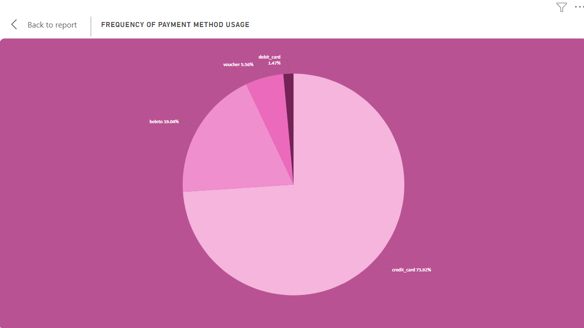

The pie chart offers an overview of payment types and their distribution among customers, providing key insights into transaction preferences.

Credit card emerges as the most popular payment method constituting the majority of transactions and representing approximately 73.9% of the customer base. Boleto follows as the second most preferred payment type accounting for around 19.0% of the total customers. Overall, the visualization highlights the dominance of credit card payments, suggesting a preference for convenience and flexibility among customers.

1. PRODUCT RATING ANALYSIS

Determine the top 10 highest-rated products and the bottom 10 lowest-rated products using a bar or column chart.



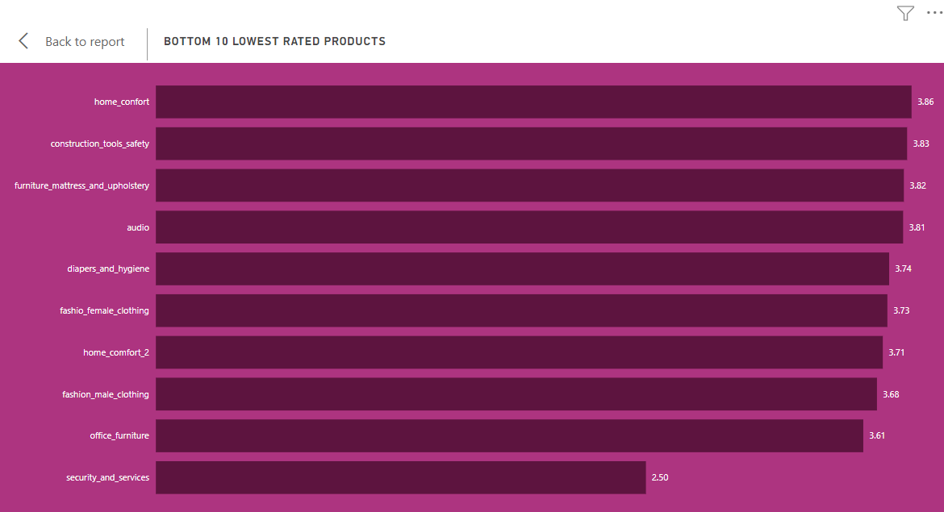

The bar chart visualises the top 10 product categories by average ratings. CDS_DVDS_MUSICALS has the highest average rating (4.7) followed closely by the visible categories along with the bottom 10 rated products where Security_and_services has the least rating(2.50) among all categories.

1. STATE-WISE SALES ANALYSIS

Identify and visually represent states with high and low sales, providing a clear understanding of regional sales performance.

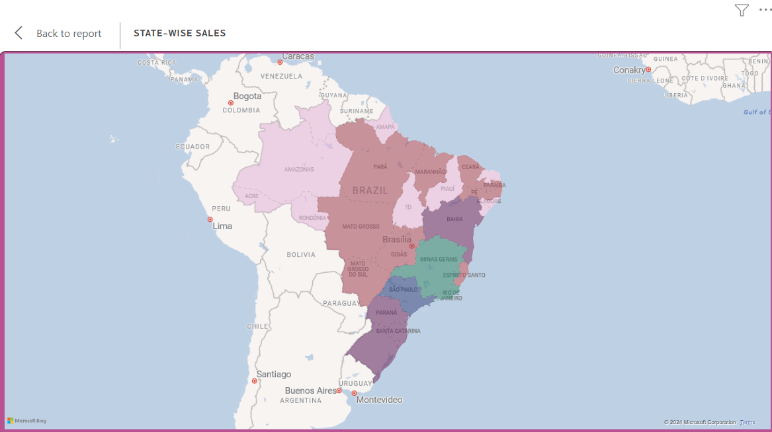

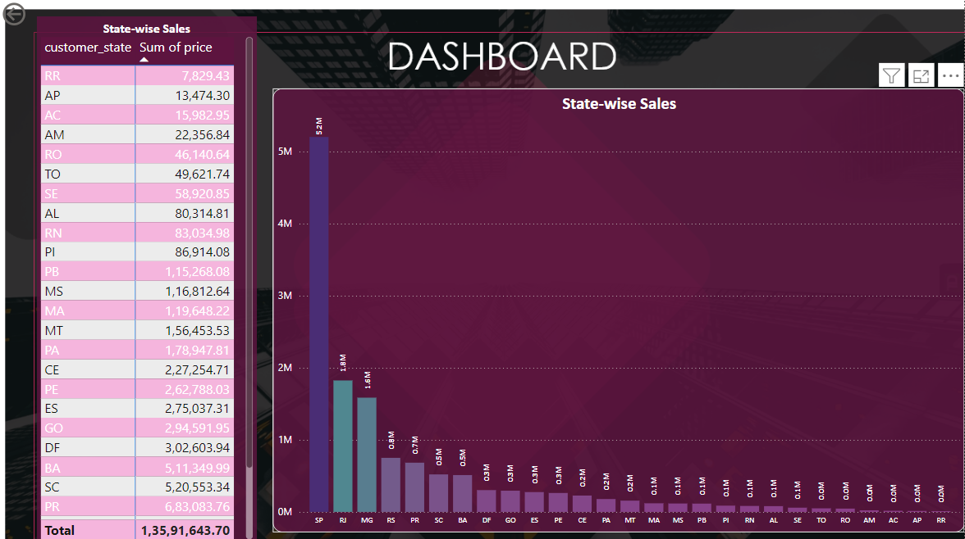

The map chart provides a comprehensive overview of sales performance across various states, highlighting notable variations in revenue generation. São Paulo (SP) emerges as the top-performing state, with sales exceeding $5.20 million. Roraima records sales of $0.007 million contributing less than 0.1% of the total revenue.

1. SEASONAL SALES PATTERNS

Investigate and visualize any seasonal patterns (Quarterly) or trends in sales data over the course of the year.

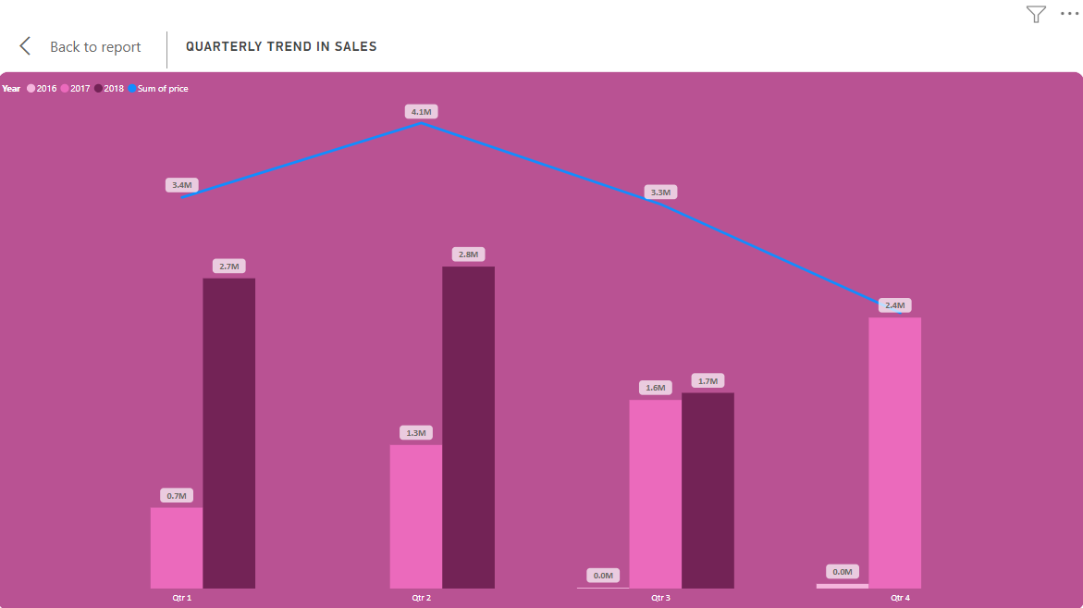

The combo chart provides a comprehensive overview of quarterly sales data across different years, offering valuable insights into sales performance over time. The bar charts represent year-wise quarter-wise sales, showcasing distinct trends for each quarter. Notably, there is a clear upward trend in sales across all quarters, with significant fluctuations observed between different years. For instance, in the first quarter, sales surged from $0.71 Million in 2017 to $2.7 Million in 2018, indicating substantial growth year over year. Similarly, sales in the second quarter increased from $1.25 Million in 2017 to $2.81 Million in 2018, reflecting continued expansion and market demand.

1. REVENUE ANALYSIS

Determine the total revenue generated by ShopNest Store and analyse how it changes over time (Yearly). Represent this information through suitable visuals to highlight trends and patterns.

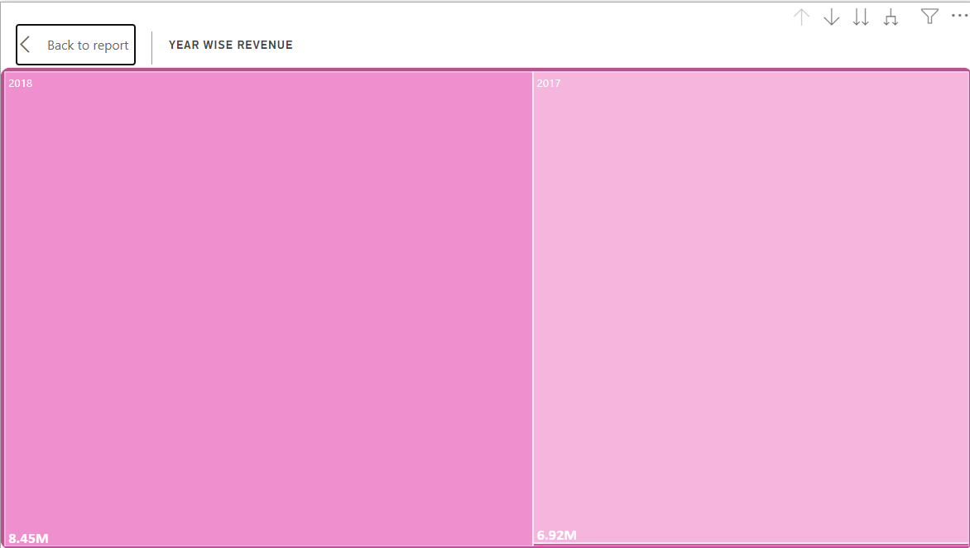

The tree chart provides a visual representation of revenue trends across different years, offering insightful observations into revenue performance over time. Notably, there is a significant increase in revenue from 2016 to 2017, with revenue soaring from $47k in 2016 to $6.92 Million in 2017, showcasing a substantial growth trajectory.